**LAB 07 – PS**

**NAME - Jayasingha J N D – IT24103662**

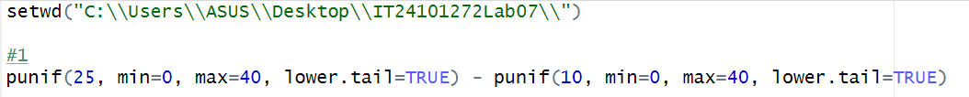



02)





03)

[i]





[ii]



